Question 4:
Make a dictionary of five subjects and their marks. Check using if-else whether a key named Math exists.
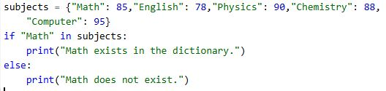
Output:
